**Project Report**

On

**DSBDAL Case Study Project**

By

Giramkar Shrushti Ankush

Roll No: 19

Under the guidance

of

**Prof. Bhosale S. S.**

Year of Submission: 2023-2024



HSBPVT’S

PARIKRAMA FACULTY OF ENGINEERING, KASHTI

DEPARMENT OF COMPUTER ENGINEERING

**HSBPVT’s GOI Faculty of Engineering, Kashti**

DEPARTMENT OF COMPUTER ENGINEERING

KASHTI



This is to certify that **Miss. Giramkar Shrushti Ankush** from **Third Year Computer Engineering** has successfully completed her seminar work titled **“DSBDAL Case Study Project”** HSBPV’ College of Engineering, Kashti in the partialfulfilment of the Bachelor’s Degree in Engineering of Savitribai Phule Pune University.

Proff. Bhosale.S. S Proff. Hiranwale.S. B

**Guide Name HOD Principal**

**INDEX**

|  |  |
| --- | --- |
| Sr. No | Title |
| 1. | Introduction |
| 2. | Phases of GINA |
| 3. | Discovery Phase |
| 4. | Data Preparation Phase |
| 5. | Model Planning Phase |
| 6. | Model Building Phase |
| 7. | Communicate Result Phase |
| 8. | Operationalize Phase |
| 9. | Chart |
| 10. | Conclusion |

**INTRODUCTION**

**GINA**, the Global Innovation Network and Analysis, is a comprehensive initiative undertaken by organizations to leverage data analytics and network analysis techniques to drive innovation and strategic decision-making across their global operations. GINA aims to harness the collective knowledge, expertise, and resources within an organization's global network to identify opportunities, mitigate challenges, and accelerate the pace of innovation.

At its core, **GINA** involves collecting, integrating, and analyzing data from various internal and external sources to gain insights into market trends, consumer preferences, technological advancements, and internal capabilities. This data-driven approach enables organizations to identify emerging opportunities, anticipate future trends, and make informed decisions about resource allocation, product development, and strategic partnerships.

**Key components of the GINA initiative may include:**

1. **Data Collection and Integration:**

Gathering data from diverse sources such as R&D reports, customer feedback, market research, competitor analyses, and industry trends to create a comprehensive dataset for analysis.

1. **Analytical Modeling:**

Applying advanced analytics techniques such as network analysis, text mining, natural language processing (NLP), predictive analytics, and machine learning to derive insights from the data and identify patterns, trends, and relationships.

1. **Insights Generation:**

Interpreting the results of the analysis to generate actionable insights and recommendations for innovation initiatives, resource allocation, and strategic decision-making.

1. **Collaboration and Knowledge Sharing:**

Fostering collaboration and knowledge sharing among global teams and stakeholders by connecting relevant experts, facilitating communication, and promoting interdisciplinary collaboration.

1. **Strategic Planning and Implementation:**

Developing strategic plans and action plans based on the insights generated from GINA analysis and implementing initiatives to drive innovation and business growth.

**Benefits of GINA:**

* **Enhanced Innovation Capabilities:**

GINA enables organizations to unlock their full innovation potential by leveraging data-driven insights and fostering collaboration across global teams.

* **Improved Decision Making:**

By providing actionable insights into market trends, consumer preferences, and technological advancements, GINA helps organizations make informed decisions that drive business growth.

* **Optimized Resource Allocation:**

GINA allows organizations to allocate resources more effectively by identifying high-potential innovation opportunities and prioritizing investments accordingly.

* **Competitive Advantage:**

Organizations that successfully implement GINA gain a competitive edge in their industries by staying ahead of market trends, anticipating customer needs, and delivering innovative solutions more rapidly than competitors.

GINA is a comprehensive framework designed to enable organizations to leverage data analytics, network analysis, and advanced technologies to drive innovation and strategic decision-making across their global operations. By harnessing the collective knowledge, expertise, and resources within an organization's global network, GINA aims to identify opportunities, mitigate challenges, and accelerate the pace of innovation. By implementing the GINA initiative, organizations can unlock their full innovation potential, capitalize on emerging opportunities, and maintain a competitive edge in today's rapidly evolving business landscape

**PHASES OF GINA**

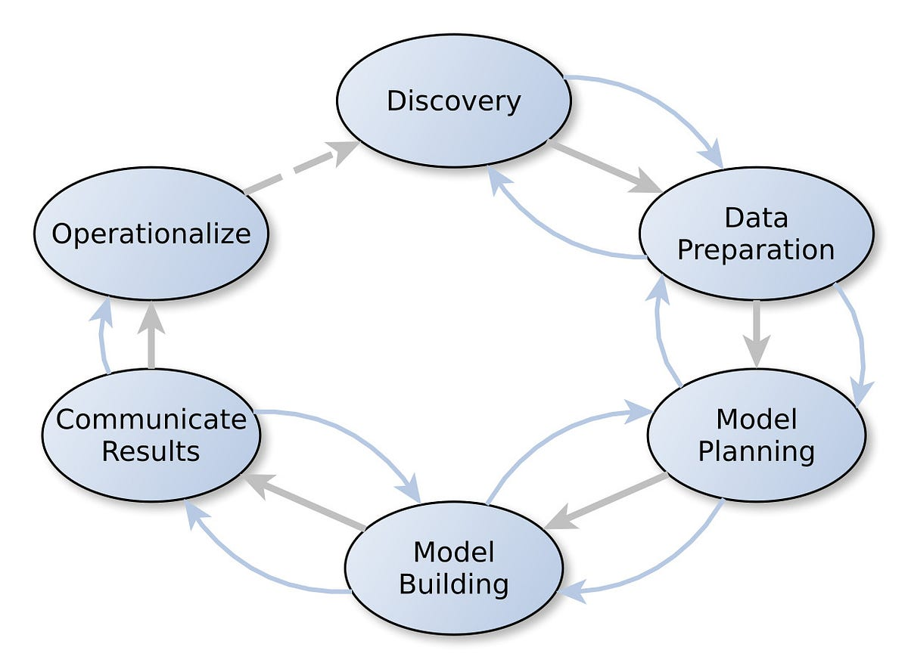

**There are Six Phases of GINA:**

1. Discovery Phase.
2. Data Preparation Phase.
3. Model Planning Phase.
4. Model Building Phase.
5. Communicate Results Phase.
6. Operationalize Phase.

* **Discovery phase:**

The Discovery Phase of the Global Innovation Network and Analysis (GINA) initiative serves as the foundational stage where the organization identifies and defines the key business problems, objectives, and challenges that GINA aims to address. This phase sets the direction for the entire initiative and ensures alignment with the organization's strategic goals. Here's an overview of the key components of the GINA Discovery Phase:

**1. Stakeholder Engagement:**

The first step in the Discovery Phase involves engaging stakeholders from across the organization, including executives, business leaders, R&D teams, and other key departments. Stakeholder interviews, workshops, and focus groups are conducted to gather insights into the organization's innovation goals, pain points, and strategic priorities. This helps ensure that the objectives of the GINA initiative are aligned with the broader business strategy and address the most pressing needs of the organization.

**2. Problem Framing and Definition:**

Once stakeholders are engaged, the focus shifts to framing and defining the specific business problems and objectives that GINA will address. This involves conducting a thorough analysis of the current state of innovation within the organization, identifying gaps and bottlenecks, and articulating clear and actionable problem statements. For example, the organization may seek to improve collaboration between global R&D teams, accelerate the pace of innovation, or leverage data analytics to gain insights into market trends and consumer preferences.

**3. Goal Setting and Objective Alignment:**

With the business problems identified, the next step is to set specific goals and objectives for the GINA initiative. These goals should be SMART (Specific, Measurable, Achievable, Relevant, Time-bound) and aligned with the organization's overall strategic objectives. For instance, goals may include increasing the number of successful product launches, reducing time-to-market for new innovations, or improving the efficiency of R&D processes.

**4. Establishing Success Metrics:**

In parallel with goal setting, the organization defines key performance indicators (KPIs) and success metrics to measure the effectiveness and impact of the GINA initiative. These metrics should be quantifiable, relevant to the defined objectives, and track progress over time. Examples of success metrics may include innovation pipeline velocity, cross-functional collaboration scores, ROI on R&D investments, or market share gains attributable to new product innovations.

**5. Assessing Organizational Readiness:**

As part of the Discovery Phase, the organization evaluates its readiness to undertake the GINA initiative successfully. This involves assessing factors such as organizational culture, leadership support, resource availability, data infrastructure, and technological capabilities. Identifying potential barriers or challenges early on allows the organization to proactively address them and ensure a smoother implementation process.

**6. Developing a Roadmap and Action Plan:**

Finally, the Discovery Phase concludes with the development of a comprehensive roadmap and action plan for the GINA initiative. This roadmap outlines the sequence of activities, milestones, and timelines for the initiative, as well as the roles and responsibilities of key stakeholders involved. The action plan defines specific tasks, deliverables, and dependencies, ensuring that the GINA initiative progresses in a structured and coordinated manner.

* **Data Preparation Phase:**

The Data Preparation phase of the Global Innovation Network and Analysis (GINA) initiative is a crucial step in the analytical process. This phase involves transforming raw data into a format that is suitable for analysis, ensuring its quality, consistency, and relevance to the objectives of the initiative. Here's an overview of the key steps involved in the Data Preparation phase of GINA:

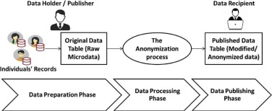

* **Data Collection and Integration:**

The first step in the Data Preparation phase is to collect data from various internal and external sources relevant to the organization's innovation ecosystem. This includes R&D reports, customer feedback, market research data, competitor analyses, industry reports, and academic publications. The collected data is then integrated into a central repository or data warehouse for further processing.

* **Data Cleaning and Validation:**

Once the data is collected, it undergoes a process of cleaning and validation to ensure its quality and integrity. This involves identifying and correcting errors, inconsistencies, and missing values in the dataset. Data validation checks are performed to verify that the data conforms to predefined standards and business rules.

* **Data Transformation and Standardization:**

After cleaning and validation, the data is transformed and standardized to ensure consistency and compatibility across different sources and formats. This may involve converting data into a common format, standardizing units of measurement, and harmonizing variable names and categories.

* **Feature Engineering:**

Feature engineering is the process of creating new features or variables from existing data to enhance the predictive power of analytical models. This may include aggregating, summarizing, or deriving new variables based on the original data. Feature engineering techniques help uncover hidden patterns and relationships within the data that may not be apparent initially.

* **Data Sampling and Splitting:**

Depending on the size and complexity of the dataset, data sampling techniques may be applied to reduce computational costs and improve efficiency. This involves selecting a representative subset of the data for analysis while preserving its essential characteristics. Additionally, the dataset may be split into training, validation, and testing sets for model development and evaluation purposes.

* **Data Privacy and Security:**

During the Data Preparation phase, measures are taken to ensure the privacy and security of sensitive data. This includes anonymizing personally identifiable information (PII), implementing access controls, encryption, and other security measures to protect data from unauthorized access or disclosure.

* **Documentation and Metadata Management:**

Throughout the Data Preparation phase, documentation and metadata management practices are followed to maintain a record of the data processing steps, transformations applied, and assumptions made. This documentation ensures transparency, reproducibility, and accountability in the analytical process.

By completing the Data Preparation phase of GINA, organizations ensure that the data is cleaned, validated, transformed, and standardized in a way that maximizes its usefulness for analysis and decision-making. This sets the stage for the subsequent phases of GINA, where advanced analytics techniques are applied to derive actionable insights and drive innovation initiatives.

By implementing the GINA initiative, organizations can unlock their full innovation potential, capitalize on emerging opportunities, and maintain a competitive edge in today's rapidly evolving business landscape. GINA enables organizations to adapt to changing market dynamics, respond to customer needs more effectively, and drive sustainable growth through continuous innovation and strategic decision-making.

This documentation ensures transparency, reproducibility, and accountability in the analytical process. By completing the Data Preparation phase of GINA, organizations ensure that the data is cleaned, validated, transformed, and standardized in a way that maximizes its usefulness for analysis and decision-making. This sets the stage for the subsequent phases of GINA, where advanced analytics techniques are applied.

* **Model Planning Phase:**

The Model Planning phase of the Global Innovation Network and Analysis (GINA) initiative involves designing the analytical models and techniques that will be used to derive insights from the prepared data. This phase is critical for ensuring that the analytical approach aligns with the objectives of the initiative and maximizes the value of the data collected. Here's an overview of the key components of the Model Planning phase:

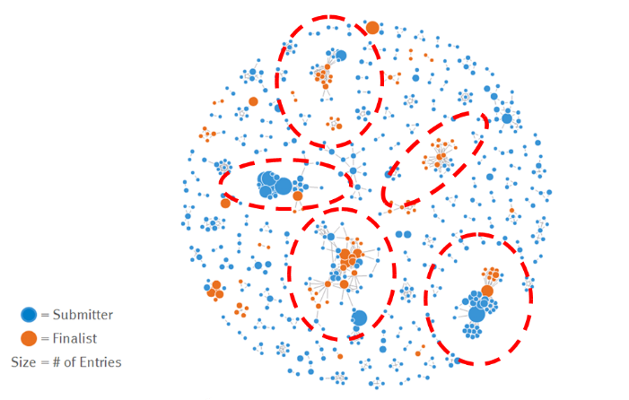

* **Understanding Business Objectives:**

The first step in the Model Planning phase is to gain a thorough understanding of the business objectives and challenges that GINA aims to address. This involves reviewing the problem statements identified during the Discovery phase and clarifying the specific questions that the analytical models will seek to answer.

* **Selecting Analytical Techniques:**

Based on the business objectives and the nature of the data collected, appropriate analytical techniques are selected for analysis. This may include:

***Descriptive analytics:***Summarizing and visualizing the data to gain insights into trends, patterns, and distributions.

***Predictive analytics:*** Developing models to forecast future outcomes or trends based on historical data.

***Prescriptive analytics:*** Recommending actions or interventions to optimize decision-making and resource allocation.

***Network analysis:*** Analyzing the relationships and interactions between different entities within the organization's innovation network.

***Text mining and natural language processing (NLP):*** Extracting insights from unstructured text data such as R&D reports, customer feedback, and social media posts.

* **Data Modeling Techniques:** Once the analytical techniques are selected, data modeling techniques are chosen to operationalize these techniques on the prepared data. This may include:

***Regression analysis:*** Modeling the relationship between dependent and independent variables to make predictions.

***Classification and clustering:*** Grouping data into meaningful categories or clusters based on similarities or patterns.

***Time series analysis:*** Analyzing time-stamped data to identify trends, seasonality, and patterns over time.

***Machine learning algorithms:*** Training algorithms to learn patterns from data and make predictions or recommendations.

* **Model Validation and Evaluation:**

Before deploying the analytical models, it is essential to validate and evaluate their performance. This involves: Splitting the data into training and testing sets to assess the model's generalization ability.

***Cross-validation:*** Repeatedly splitting the data into training and testing sets to assess the stability of the model's performance.

***Model evaluation metrics:*** Using appropriate metrics such as accuracy, precision, recall, F1-score, or area under the curve (AUC) to evaluate the model's performance.

* **Iterative Model Refinement:**

Analytical models are iteratively refined based on feedback from stakeholders and performance evaluation results. This may involve:

***Fine-tuning model parameters to improve performance.***

Experimenting with different feature sets or data transformations to enhance model accuracy. Incorporating additional data sources or variables to capture additional insights or improve model robustness.

* **Model Building Phase;**

The Model Building phase of the Global Innovation Network and Analysis (GINA) initiative involves the actual development and refinement of analytical models and algorithms to derive insights from the prepared data. This phase is crucial for translating the planned analytical approach into tangible models that can generate actionable insights. Here's a detailed overview of the key components of the Model Building phase:

**1. Data Preprocessing:**

Before building analytical models, the prepared data undergoes further preprocessing to ensure its suitability for modeling. This may involve:

***Feature selection:*** Identifying the most relevant features or variables that contribute to the model's predictive power.

***Feature scaling:*** Standardizing or normalizing numerical features to ensure consistency and comparability.

***Handling imbalanced data:*** Addressing class imbalance issues in classification tasks by oversampling, under sampling, or using techniques like SMOTE (Synthetic Minority Over-sampling Technique).

***Handling categorical variables:*** Encoding categorical variables into numerical format using techniques like one-hot encoding or label encoding.

**2. Model Selection:**

Based on the planned analytical approach and business objectives, appropriate models are selected for building. This may include a combination of traditional statistical models and machine learning algorithms. Common models used in GINA include:

* Linear regression
* Logistic regression
* Decision trees
* Random forests
* Support vector machines (SVM)
* Neural networks

**3. Model Training:**

Selected models are trained on the preprocessed data using appropriate training algorithms. This involves: Splitting the data into training and validation sets.

Iteratively adjusting model parameters to minimize the difference between predicted and actual outcomes (loss function). Evaluating the model's performance on the validation set to prevent overfitting and ensure generalization to unseen data.

**4. Interpretation and Documentation:**

Once optimized, models are interpreted to extract actionable insights and recommendations. This involves: Analyzing feature importance to understand which variables have the most significant impact on the model's predictions.

Documenting model assumptions, limitations, and recommendations for stakeholders' understanding and future reference. Communicating findings to stakeholders in a clear, concise manner, using visualizations and storytelling techniques to convey insights effectively.

By following these steps in the Model Building phase, organizations can develop robust analytical models that generate actionable insights to drive innovation and strategic decision-making within the GINA framework.

**5. Model Optimization and Hyperparameter Tuning:**

Models are iteratively optimized to improve their performance and generalization ability. This may involve:

Fine-tuning model hyperparameters using techniques like grid search, random search, or Bayesian optimization. Feature engineering to create new features or modify existing ones to enhance model performance. Ensemble methods, such as bagging, boosting, or stacking, to combine multiple models for improved accuracy and robustness.

* **Communicate Results Phase:**

The Communicate Results phase of the Global Innovation Network and Analysis (GINA) initiative is crucial for effectively conveying the insights derived from the analytical models to key stakeholders within the organization. This phase focuses on translating complex analytical findings into actionable recommendations and facilitating informed decision-making. Here's an overview of the key components of the Communicate Results phase:

* **Data Visualization**:

Utilizing data visualization techniques to present the insights in a visually compelling and understandable format. This may include:

***Charts and graphs:*** Such as bar charts, line plots, scatter plots, and pie charts to represent trends, distributions, and relationships in the data.

***Dashboards:*** Interactive dashboards that allow stakeholders to explore and interact with the data dynamically.

***Heatmaps, tree maps, and geospatial visualizations:*** To visualize patterns and trends across different dimensions, regions, or categories.

***Executive Summary:*** Providing a concise summary of the key findings, insights, and recommendations for executive stakeholders. The executive summary highlights the most critical insights and their implications for strategic decision-making.

* **Insights Presentation:**

Conducting presentations or workshops to communicate the results of the analysis to relevant stakeholders. This involves:

-Tailoring the presentation to the audience's level of expertise and interest.

-Using storytelling techniques to contextualize the insights and make them relatable to the audience.

-Encouraging interactive discussions and feedback to ensure stakeholders' understanding and buy-in.

* **Actionable Recommendations:**

Offering actionable recommendations based on the insights generated from the analysis. These recommendations should be specific, feasible, and tied directly to the organization's strategic objectives. They should also consider potential risks and challenges associated with implementation.

* **Documentation and Reporting:**

Documenting the results of the analysis and recommendations in a formal report or documentation. This serves as a reference for stakeholders and ensures the findings are captured for future reference. The documentation should include:

-Detailed explanations of the analytical approach, methodologies, and assumptions made.

-Summary of the key insights, findings, and recommendations.

-Visualizations, tables, and figures supporting the analysis.

-Limitations and uncertainties associated with the analysis.

* **Feedback and Iteration:**

Seeking feedback from stakeholders on the communicated results and recommendations. This allows for clarification of any misunderstandings or misinterpretations and provides an opportunity to address additional questions or concerns. Feedback may also inform future iterations of the analysis or refine the recommendations based on stakeholders' input.

* **Knowledge Sharing and Training:**

Promoting knowledge sharing and capacity building within the organization by conducting training sessions or workshops on the analytical techniques used and the insights derived. This empowers stakeholders to leverage data-driven insights in their decision-making processes and fosters a culture of innovation and continuous learning.

By effectively communicating the results of the analysis and providing actionable recommendations, organizations can ensure that the insights derived from the GINA initiative have a tangible impact on strategic decision-making, innovation initiatives, and overall business performance.

This empowers stakeholders to leverage data-driven insights in their decision-making processes and fosters a culture of innovation and continuous learning.

* **Operationalize Phase:**

The Operationalize phase of the Global Innovation Network and Analysis (GINA) initiative focuses on translating the insights and recommendations derived from the analytical models into actionable strategies and operational plans. This phase is crucial for ensuring that the organization can effectively implement the recommendations and drive meaningful change based on the insights generated.

The operationalization phase is the sixth phase of the Global Innovation Network and Analysis (GINA) data analytics life cycle. In this phase, the team learns about the model's performance and constraints in a small production environment, and then adjusts before the full deployment. The team also delivers final reports, briefings, and codes. Here's a breakdown of the key components of the Operationalize phase:

* **Strategy Alignment:** Aligning the insights and recommendations derived from the GINA initiative with the organization's strategic objectives and priorities. This involves ensuring that the proposed actions are consistent with the overarching goals and vision of the organization.
* **Resource Allocation:** Determining the resources, including budget, personnel, and technology, required to implement the recommendations effectively. This may involve reallocating existing resources or securing additional resources as needed to support the initiatives.
* **Action Planning:** Developing detailed action plans outlining the specific steps, timelines, and responsibilities for implementing the recommendations. Action plans should be actionable, measurable, and tied directly to the identified objectives and outcomes.
* **Stakeholder Engagement:**Engaging key stakeholders across the organization to secure buy-in and support for the proposed initiatives. This may include executive sponsors, department heads, project managers, and frontline staff who will be involved in implementing the recommendations.
* **Change Management:** Implementing change management processes to facilitate the adoption of new strategies, processes, and technologies. This may involve communication plans, training programs, and performance management systems to ensure that stakeholders understand and embrace the changes.
* **Technology Integration:** Integrating the insights and recommendations derived from the GINA initiative into existing technology platforms and systems. This may involve configuring software tools, developing custom applications, or leveraging APIs to ensure seamless integration with existing workflows.
* **Monitoring and Evaluation:** Establishing mechanisms for monitoring and evaluating the implementation of the recommendations. This includes defining key performance indicators (KPIs) to track progress, conducting regular reviews and assessments, and adjusting strategies as needed based on feedback and performance data.
* **Continuous Improvement:** Fostering a culture of continuous improvement by soliciting feedback, capturing lessons learned, and iterating on the implementation of recommendations over time. This involves regularly reviewing processes, identifying areas for optimization, and making iterative adjustments to drive ongoing innovation and improvement.
* **Documentation and Reporting:** Documenting the implementation process, including action plans, progress reports, and outcomes achieved. This ensures transparency, accountability, and visibility into the impact of the GINA initiative on the organization's operations and performance.

By operationalizing the insights and recommendations derived from the GINA initiative, organizations can drive meaningful change, improve innovation capabilities, and achieve sustainable growth in today's competitive business landscape. This phase is crucial for ensuring that the organization can effectively implement the recommendations and drive meaningful change based on the insights generated.

**CASE STUDY**

**1. Discovery of Business Problem Framed:**

In today's globalized economy, businesses are constantly seeking ways to innovate and stay ahead of the competition. A multinational corporation, let's call it TechGlobal Inc., faced a critical challenge in effectively harnessing its global innovation potential. Despite having research and development (R&D) facilities across different countries, TechGlobal struggled to integrate and leverage the diverse knowledge and expertise within its network to drive innovation.

The primary business problem was identified as the lack of a cohesive framework for fostering collaboration, sharing insights, and translating diverse ideas into tangible innovations across the organization's global footprint. This issue hindered TechGlobal's ability to capitalize on emerging market trends, respond swiftly to consumer demands, and maintain its competitive edge in the rapidly evolving tech industry.

**2. Data:**

To address this challenge, TechGlobal embarked on the Global Innovation Network and Analysis (GINA) initiative. GINA aimed to collect, analyze, and utilize data from various sources within the organization's global network to facilitate innovation and drive strategic decision-making. The data sources for GINA included:

Internal R&D reports and project documentation from Tech Global's research centers worldwide. Customer feedback and market research data to identify emerging trends and consumer preferences. Employee collaboration platforms, such as internal forums, knowledge-sharing portals, and project management tools, to capture ideas and insights. External data sources, such as industry reports, academic publications, and competitor analyses, to gain broader insights into technological advancements and market dynamics.

**3. Model Planning Analytic Technique:**

The analytic technique employed in the GINA initiative comprised several key components:

* ***Network Analysis:***

Utilizing network analysis techniques to map out the connections and interactions between different R&D centers, teams, and individuals within TechGlobal's global innovation network. This helped identify central nodes, key influencers, and communication bottlenecks within the organization.

* ***Text Mining and Natural Language Processing (NLP):***

Applying text mining and NLP algorithms to extract insights from unstructured data sources, such as R&D reports, customer feedback, and employee discussions. This enabled TechGlobal to identify recurring themes, emerging technologies, and potential innovation opportunities hidden within vast amounts of textual data.

* ***Predictive Analytics:***

Leveraging predictive analytics models to forecast market trends, anticipate consumer demands, and identify potential areas for future innovation. By analyzing historical data and external market indicators, TechGlobal could make data-driven decisions and allocate resources more effectively to capitalize on emerging opportunities.

* ***Machine Learning Algorithms:*** Employing machine learning algorithms to develop recommendation systems and predictive models that could suggest relevant research topics, potential collaborators, and innovation pathways based on past performance and existing knowledge within the organization.
* ***Results and Key Findings:***

The implementation of the GINA initiative yielded several significant results and key findings for TechGlobal Inc.: Enhanced Collaboration: GINA facilitated improved collaboration and knowledge sharing across TechGlobal's global R&D network by identifying and connecting relevant experts, teams, and resources.

* ***Insights-Driven Innovation:***

By leveraging advanced analytics techniques, GINA enabled TechGlobal to uncover valuable insights from both internal and external data sources. These insights helped identify emerging market trends, customer preferences, and technological advancements, guiding the development of new products and services that better aligned with market needs.

* ***Optimize Resource Allocation:***

GINA's predictive analytics capabilities allowed TechGlobal to optimize resource allocation by prioritizing R&D projects with the highest potential for impact and ROI. This helped streamline innovation efforts and maximize the utilization of limited resources across the organization's global network.

* ***Competitive Advantage:***

Through GINA, TechGlobal gained a competitive advantage in the tech industry by staying ahead of market trends, anticipating consumer demands, and delivering innovative solutions more rapidly than competitors. This strengthened TechGlobal's position as a leader in the global innovation landscape and contributed to its long-term growth and sustainability.

**4. Implementation and Integration Phase:**

In the implementation and integration phase, the organization operationalizes the insights and recommendations derived from the GINA initiative into its business processes and practices. This may involve updating R&D strategies, reallocating resources, establishing cross-functional collaboration initiatives, and integrating analytics capabilities into existing systems and workflows.

**5. Monitoring and Continuous Improvement Phase:**

Finally, the organization establishes mechanisms for monitoring the performance and impact of the GINA initiative over time. This may involve tracking key performance indicators (KPIs), conducting regular reviews and evaluations, soliciting feedback from stakeholders, and iterating on the initiative based on lessons learned and evolving business needs. The goal of this phase is to ensure that the GINA initiative remains aligned with the organization's strategic objectives and continues to drive innovation and value creation into the future.

|  |  |
| --- | --- |
| Components of Analytic Plan | GINA Case Study |
| Discovery Business Problem Framed | Tracking global knowledge growth, ensuring effective knowledge transfer and quickly converting it into corporate assets. Executing on these three elements should accelerate innovation. |
| Initial Hypotheses | An increase in geographic knowledge transfer  improves the speed of idea delivery. |
| Data | Five years of innovation idea submissions and history, six months of textual notes from global innovation and research activities |
| Model Planning Analytic Technique | Social network analysis, social  graphs, clustering and regression analysis |
| Results and Key Findings | 1. Identified hidden, high –value innovators and found ways to share their knowledge.  2. Informed investment decisions in university  research projects  3. Created tools to help submitters |

**CONCLUSION:**

GINA (Global Innovation Network and Analysis) is a tool that provides insights and analysis to support innovation and technology development. It enables companies and organizations to stay up-to-date with the latest industry trends and technology advancements, allowing them to make informed decisions and stay competitive in their respective fields. The platform offers a range of features, including technology scouting, competitor analysis, and IP portfolio management, and can be customized to suit the needs of individual companies. Overall, GINA is a valuable resource for companies looking to innovate and stay ahead of the curve in their industries.In conclusion, the Global Innovation Network and Analysis (GINA) initiative represents a comprehensive approach for organizations to harness the power of data analytics, network analysis, and advanced technologies to drive innovation and strategic decision-making. Throughout its phases, GINA enables organizations to address key business challenges, unlock insights from diverse data sources, develop robust analytical models, and operationalize recommendations for tangible impact.